Description of the device for development of concentrations PRK - 1U
Development of concentrations providing eternal life for all is carried out by the concentration of attention on the receiver of generated bio-signal and in the same time control for achieving result of the concentrations. It is known in psychology that the longer the concentration is carried out, the faster the goal is achieved, and the events are optimized. The device, in addition to this factor of psychology, according to the law of universal connections has a control of the goal of concentration through superposition of the fields from generation of the bio-signal, electromagnetic fields. The device develops concentrations of creative control.
The device has been created by Grigori Grabovoi on the bases on his two currently effective patented inventions: “Method of prevention of catastrophes and the device for its realization” and “Information transmission system”.
In the patent “Information transmission system” has been written that it is known in the theory of wave synthesis that a thought generated emission may exist in two quantum states simultaneously. One of these states is located on the sensor element of the transmitter of the signals and another on the receiver of the signals. This makes it possible to create devices for ensuring eternal life, which interact with thinking. In the patented inventions of Grigori Grabovoi it is written that human operator generates information in the form of the emission of thought. In order to activate the function of the device “PRK - 1U” a person concentrates emission of creative thought on the lenses located on the upper surface of the device.

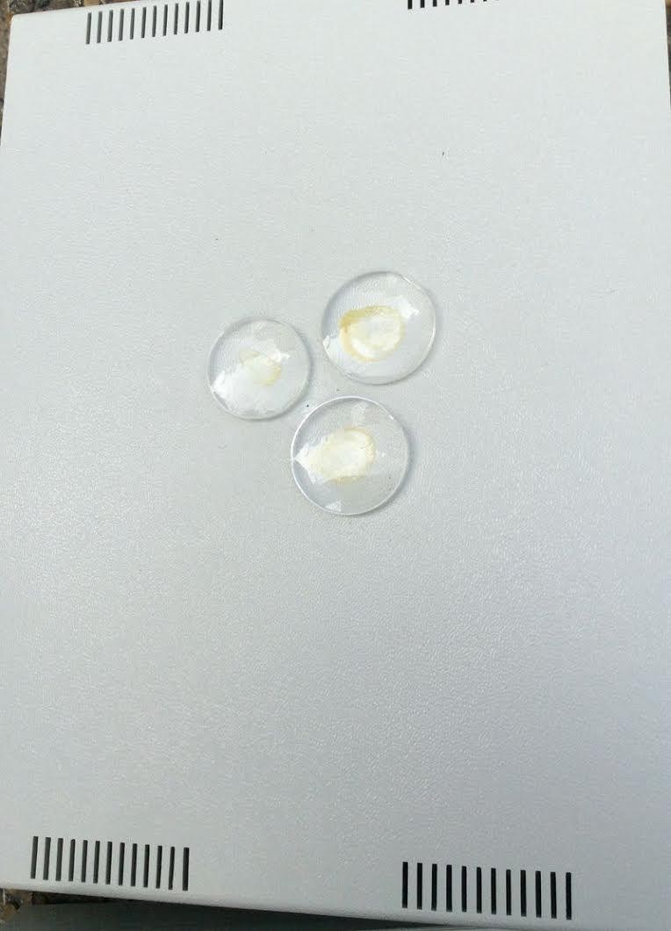

Thought contains a goal of concentration. The action of concentration for the current and future time is made on the sensor element of the transmitter of signals consisting of lenses. Circular movements of concentrations starting from smaller diameter lens are carried out counter-clockwise above the lenses of a bigger diameter.
At concentrations related to the events of the past, the circular motion of the thought of concentration was performed clockwise starting from the smaller lens to the larger lens. And the ray of concentration in this case was not on the top, as in the case of

concentrations for the current and future time, but from the inner optical assembly of the device.
In accordance with the system of transmission of information described in the patent, second quantum state of thought is projected onto the receiver of signals arranged in the form of optical device inside the device:
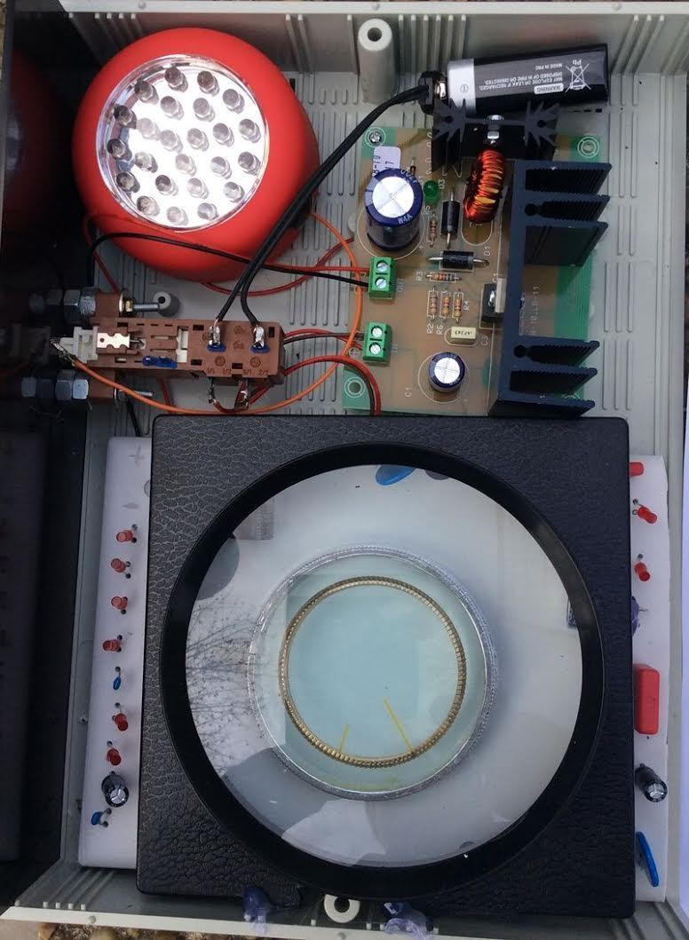

Realization of the method of normalization, during the concentration described in the patent “Method of prevention of catastrophes and device for its realization” is carried out

through superposition of the bio-signal generated fields, electromagnetic fields. In addition to the factor of psychology according to the law of action of universal connections, a control of the goal of concentration is added.
The device universally works for the development of the following concentrations ensuring eternal life:

Control 1:
Development of eternal life concentrations for any event. Control 2:
Development of eternal life concentrations for controlling clairvoyance Control 3:
Development of eternal life concentrations for controlling forecasting. Control 4:
Development of eternal life concentrations for rejuvenation.

The inventor of the device “PRK – 1U” is Grigori Petrovich Grabovoi

The producer of the device is Individual entrepreneur "GRIGORII GRABOVOI PR KONSALTING TECHNOLOGIES OF ETERNAL DEVELOPMENT" who operates on the basis of the certificate of state registration of individual Grigori Petrovich Grabovoi as an individual entrepreneur №63983276 issued on September 21. 2015 by the Agency for the registration of enterprises of the Republic of Serbia.
The methods of use of the device:
Methods of use were the following: concentration on the goal of control 1, 2, 3, 4 is carried out within the time interval from 1 to 3 minutes, and if necessary longer, without the turned on device and when the device is turned on. The results are compared in terms of development effect concentrations ensuring eternal life. This effect is used for the development of concentrations on specified directions through repeated use.
The results of the use of the appliance:

Control 1: Development of concentrations of eternal life for any event. Comparison of concentration before switching on the device and concentration during operation of the device established that a support at the concentration occurs, there is a feeling of energy flow, spiritual and creative capabilities increase.
Control 2: Development of concentrations of eternal life for controlling clairvoyance Comparison of concentration before switching on the device and concentration during operation of the device established that during operation of the device the flat images perceived by the controlling clairvoyance from become voluminous, more stable and clear, controllability increases, the increase of the image through magnifying glass effect occurs.
Control 3: Development of concentrations of eternal life for controlling forecasting. Comparison of concentration before switching on the device and concentration during operation of the device established that during operation of the device the information of the controlling forecasting becomes controllable more harmoniously based on the form similar to damp dynamic matter, the capability of developing controlling concentrations on more distant into the future events increases.
Control 4: Development of concentrations of eternal life for rejuvenation.
Comparison of concentration before switching on the device and concentration during operation of the device established that during operation of the device concentration on rejuvenation is strengthened, energy potential increases, and a person may feel a state of an earlier age.
The device meets the demanding standards. We accept orders for purchase of the device of development of concentrations “PRK-1U”. Before purchasing the device we accepted the information to customize your device. When you purchase the device purchaser the device is used in the sales office, because the device refers to complex technical devices responsive to individual radiation of thoughts. If there is the necessary result of the use by the buyer, the device is sold to the buyer.

To the administration of GRIGORII GRABOVOI PR KONSALTING TECHNOLOGIES OF ETERNAL DEVELOPMENT,11102, Kneza Mihaila 21A, TC Milenijum, lok.113 Belgrade, Serbia,
Email: grigorii.grabovoi.pr@gmail.com Skype: grigori.grabovoi.pr
Phone :+381628720443

From:

Email: _

Skype:
Phone: _

APPLICATION

for the custom made development based on individual data, production and supply of the device for development of concentrations PRK -1U and for the supply of flash stick with all materials of Education program on Teaching of Grigori Grabovoi under the license agreement.

Information’s on the application:

- The number of devices and thus flash sticks:

- How many people will in a group up to 8 use a single device:

- How long is the Teachings of Grigori Grabovoi practised: _ _

- Where is information on the possibilities of the application for purchasing acquired - indicate the source of information:

- Language of testing of the device:

- Time and date of tеsting:

- Type of testing: Via video call or personally in the office:

Date of application:

Signature: / /

To the administration of

GRIGORII GRABOVOI PR KONSALTING TECHNOLOGIES

OF ETERNAL DEVELOPMENT,

11102, Kneza Mihaila 21A, TC Milenijum, lok.113 Belgrade, Serbia,
Email: grigorii.grabovoi.pr@gmail.com Skype: grigori.grabovoi.pr
Phone :+381628720443

From:

Email:

Skype:
Phone:

Appendix to the APPLICATION from 2016.

for the custom made development based on individual data, production and supply of the device for development of concentrations PRK -1U and for the supply of flash stick with all materials of Education program on Teaching of Grigori Grabovoi under the license agreement.

Data for participants of testing:

Firs Name and Second Name Date of Birth Skype

1.

2.

3.

4.

5.

6.

7.

8.

Date of application:

Signature: / _ /

Recommendations for concentrations during the testing of the device for development of concentration PRK-1U:

Control 1:

Development of eternal life concentrations on any event. Recommendation:
At the beginning it is necessary to concentrate on localized part of the matter of one`s own organism. Then such a concentration can be done for others. After that you can concentrate on any desired event.

Control 2:

Development of eternal life concentrations on controlling clairvoyance.

At the beginning it is necessary to apply controlling clairvoyance to see in the present moment room which you came from or where you have been few hours before. Then it is possible to apply controlling clairvoyance related to any event, preferable setting the goal of control which you need to have realised. During the observation of the event in the application of controlling clairvoyance concentrations it is possible, If necessary, to correct the event. That is because controlling clairvoyance differs from common clairvoyance in such a way that when applying controlling clairvoyance it contains, simultaneously with the observation of the event, also a correction of the event in order to ensure eternal life, if it is necessary.

Control 3:

Development of eternal life concentrations on controlling forecasting.

In controlling forecasting control there should be imbedded goal of control to, with the help of the device, develop consciousness and spirit to such a level that it is possible in perspective to practise without device, using development of spirit and consciousness only.

Recommendation:

It is possible, through development of concentrations for ensuring eternal life for all, to look into the more distant future. During the observation it is possible to immediately correct the event if necessary.

Control 4:

Development of eternal life concentrations on rejuvenation. Recommendation:
You can concentrate on rejuvenation of yourself, then on rejuvenation of others. If you think that you are young and that you don’t need rejuvenation now, then you need to practice concentrations for training. Then in the future, when you would want to rejuvenate yourself, you will already know how to do it.

During those concentrations it is possible to imagine desired age and during concentrations to sense it to the level of real perception of yourself in that age.

Protocol of testing the device for development of concentration PRK-1U in physical presence of operator

Test is conducted by the citizen of the state of:

First name: Second name:

Passport number:

E-mail:

Address where testing was conducted:

Description of the device:

Development of concentrations providing eternal life for all is carried out by the concentration of attention on the receiver of generated bio-signal and in the same time control for achieving result of the concentrations. It is known in psychology that the longer the concentration is carried out, the faster the goal is achieved, and the events are optimized. The device, in addition to this factor of psychology, according to the law of universal connections has a control of the goal of concentration through superposition of the fields from generation of the bio-signal, electromagnetic fields. The device develops concentrations of creative control.
The device has been created by Grigori Grabovoi on the bases on his two currently effective patented inventions: “Method of prevention of catastrophes and the device for its realization” and “Information transmission system”.
In the patent “Information transmission system” has been written that it is known in the theory of wave synthesis that a thought generated emission may exist in two quantum

states simultaneously. One of these states is located on the sensor element of the transmitter of the signals and another on the receiver of the signals. This makes it possible to create devices for ensuring eternal life, which interact with thinking. In the patented inventions of Grigori Grabovoi it is written that human operator generates information in the form of the emission of thought. In order to activate the function of the device “PRK - 1U” a person concentrates emission of creative thought on the lenses located on the upper surface of the device.

Thought contains a goal of concentration. The action of concentration for the current and future time is made on the sensor element of the transmitter of signals consisting of lenses. Circular movements of concentrations starting from smaller diameter lens are carried out counter-clockwise above the lenses of a bigger diameter.
At concentrations related to the events of the past, the circular motion of the thought of concentration was performed clockwise starting from the smaller lens to the larger lens. And the ray of concentration in this case was not on the top, as in the case of concentrations for the current and future time, but from the inner optical assembly of the device.
In accordance with the system of transmission of information described in the patent, second quantum state of thought is projected onto the receiver of signals arranged in the form of optical device inside the device:

Realization of the method of normalization, during the concentration described in the patent “Method of prevention of catastrophes and device for its realization” is carried out through superposition of the bio-signal generated fields, electromagnetic fields. In addition to the factor of psychology according to the law of action of universal connections, a control of the goal of concentration is added.
The device universally works for the development of the following concentrations ensuring eternal life:

Control 1:
Development of eternal life concentrations for any event. Control 2:
Development of eternal life concentrations for controlling clairvoyance Control 3:
Development of eternal life concentrations for controlling forecasting. Control 4:
Development of eternal life concentrations for rejuvenation.

The inventor of the device “PRK – 1U” is Grigori Petrovich Grabovoi

The producer of the device is Individual entrepreneur "GRIGORII GRABOVOI PR KONSALTING TECHNOLOGIES OF ETERNAL DEVELOPMENT" who operates on the basis of the certificate of state registration of individual Grigori Petrovich Grabovoi as an individual entrepreneur №63983276 issued on September 21. 2015 by the Agency for the registration of enterprises of the Republic of Serbia.
Time of the testing of the device:

Date:

Time:

The methods of use of the device:

Methods of use were the following: concentration on the goal of control 1, 2, 3, 4 is carried out within the time interval from 1 to 3 minutes and longer if necessary, with the device switched off and with the device switched on. The results are compared in terms of development effect of the concentrations ensuring eternal life. This effect is applied for the development of concentrations on specified controls through repeated use of the device.

The results of the use of the appliance:

Control 1:
Development of eternal life concentrations for any event.

Description of concentration before switching on the device:

Description of concentrations after switching on the device:

Conclusion:

Control 2:
Development of eternal life concentrations for controlling clairvoyance Description of concentration before switching on the device:

Description of concentrations after switching on the device:

Conclusion:

Control 3:
Development of eternal life concentrations for controlling forecasting. Description of concentration before switching on the device:

Description of concentrations after switching on the device:

Conclusion:

Control 4:
Development of concentrations of eternal life for rejuvenation. Description of concentration before switching on the device:

Description of concentrations after switching on the device:

Conclusion:

The general conclusion about the operability of the device on the development of the concentrations of eternal life:

Date:

First name: Second name

Protocol of testing the device for development of concentration PRK-1U. Distance test.

Test is conducted by the citizen of the state of:

First name: Second name:

Passport number:

E-mail:

Address where testing was conducted:

Description of the device:

Development of concentrations providing eternal life for all is carried out by the concentration of attention on the receiver of generated bio-signal and in the same time control for achieving result of the concentrations. It is known in psychology that the longer the concentration is carried out, the faster the goal is achieved, and the events are optimized. The device, in addition to this factor of psychology, according to the law of universal connections has a control of the goal of concentration through superposition of the fields from generation of the bio-signal, electromagnetic fields. The device develops concentrations of creative control.
The device has been created by Grigori Grabovoi on the bases on his two currently effective patented inventions: “Method of prevention of catastrophes and the device for its realization” and “Information transmission system”.
In the patent “Information transmission system” has been written that it is known in the theory of wave synthesis that a thought generated emission may exist in two quantum

states simultaneously. One of these states is located on the sensor element of the transmitter of the signals and another on the receiver of the signals. This makes it possible to create devices for ensuring eternal life, which interact with thinking. In the patented inventions of Grigori Grabovoi it is written that human operator generates information in the form of the emission of thought. In order to activate the function of the device “PRK - 1U” a person concentrates emission of creative thought on the lenses located on the upper surface of the device.

Thought contains a goal of concentration. The action of concentration for the current and future time is made on the sensor element of the transmitter of signals consisting of lenses. Circular movements of concentrations starting from smaller diameter lens are carried out counter-clockwise above the lenses of a bigger diameter.
At concentrations related to the events of the past, the circular motion of the thought of concentration was performed clockwise starting from the smaller lens to the larger lens. And the ray of concentration in this case was not on the top, as in the case of concentrations for the current and future time, but from the inner optical assembly of the device.
In accordance with the system of transmission of information described in the patent, second quantum state of thought is projected onto the receiver of signals arranged in the form of optical device inside the device:

Realization of the method of normalization, during the concentration described in the patent “Method of prevention of catastrophes and device for its realization” is carried out through superposition of the bio-signal generated fields, electromagnetic fields. In addition to the factor of psychology according to the law of action of universal connections, a control of the goal of concentration is added.
The device universally works for the development of the following concentrations ensuring eternal life:

Control 1:
Development of eternal life concentrations for any event. Control 2:
Development of eternal life concentrations for controlling clairvoyance Control 3:
Development of eternal life concentrations for controlling forecasting. Control 4:
Development of eternal life concentrations for rejuvenation.

The inventor of the device “PRK – 1U” is Grigori Petrovich Grabovoi

The producer of the device is Individual entrepreneur "GRIGORII GRABOVOI PR KONSALTING TECHNOLOGIES OF ETERNAL DEVELOPMENT" who operates on the basis of the certificate of state registration of individual Grigori Petrovich Grabovoi as an individual entrepreneur №63983276 issued on September 21. 2015 by the Agency for the registration of enterprises of the Republic of Serbia.
Time of the testing of the device:

Date:

Time:

The methods of use of the device:

Methods of use were the following: concentration on the goal of control 1, 2, 3, 4 is carried out within the time interval from 1 to 3 minutes and longer if necessary, with the device switched off and with the device switched on. The results are compared in terms of development effect of the concentrations ensuring eternal life. This effect is applied for the development of concentrations on specified controls through repeated use of the device.

Images of the device with the lenses located on the top surface of the instrument: to be seen through the video call of Skype. Switching the instrument was carried out on the reported willingness to perform tests in accordance with the test program.

The results of the use of the appliance:

Control 1:
Development of eternal life concentrations for any event.

Description of concentration before switching on the device:

Description of concentrations after switching on the device:

Conclusion:

Control 2:
Development of eternal life concentrations for controlling clairvoyance Description of concentration before switching on the device:

Description of concentrations after switching on the device:

Conclusion:

Control 3:
Development of eternal life concentrations for controlling forecasting. Description of concentration before switching on the device:

Description of concentrations after switching on the device:

Conclusion:

Control 4:
Development of concentrations of eternal life for rejuvenation. Description of concentration before switching on the device:

Description of concentrations after switching on the device:

Conclusion:

The general conclusion about the operability of the device on the development of the concentrations of eternal life:

Date:

First name: Second name

