Protocol of testing the device for development of concentration
PRK-1U in physical presence of operator

Test is conducted by the citizen of the state of:

First name:__________________________Second name:____________________________
Passport number:____________________________________________________________
E-mail:_____________________________________________________________________
Address where testing was conducted:

Description of the device:

Development of concentrations providing eternal life for all is carried out by the concentration of attention on the receiver of generated bio-signal and in the same time control for achieving result of the concentrations. It is known in psychology that the longer the concentration is carried out, the faster the goal is achieved, and the events are optimized. The device, in addition to this factor of psychology, according to the law of universal connections has a control of the goal of concentration through superposition of the fields from generation of the bio-signal, electromagnetic fields. The device develops concentrations of creative control.
The device has been created by Grigori Grabovoi on the bases on his two currently effective patented inventions: “Method of prevention of catastrophes and the device for its realization” and “Information transmission system”.
In the patent “Information transmission system” has been written that it is known in the theory of wave synthesis that a thought generated emission may exist in two quantum states simultaneously. One of these states is located on the sensor element of the transmitter of the signals and another on the receiver of the signals. This makes it possible to create devices for ensuring eternal life, which interact with thinking. In the patented inventions of Grigori Grabovoi it is written that human operator generates information in the form of the emission of thought. In order to activate the function of the device “PRK - 1U” a person concentrates emission of creative thought on the lenses located on the upper surface of the device.

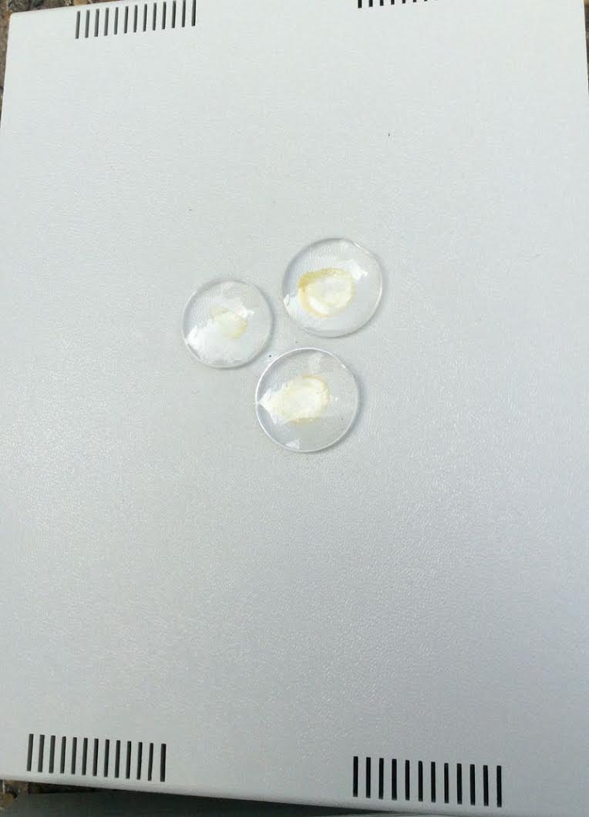

Thought contains a goal of concentration. The action of concentration for the current and future time is made on the sensor element of the transmitter of signals consisting of lenses. Circular movements of concentrations starting from smaller diameter lens are carried out counter-clockwise above the lenses of a bigger diameter.
At concentrations related to the events of the past, the circular motion of the thought of concentration was performed clockwise starting from the smaller lens to the larger lens. And the ray of concentration in this case was not on the top, as in the case of concentrations for the current and future time, but from the inner optical assembly of the device.
In accordance with the system of transmission of information described in the patent, second quantum state of thought is projected onto the receiver of signals arranged in the form of optical device inside the device:
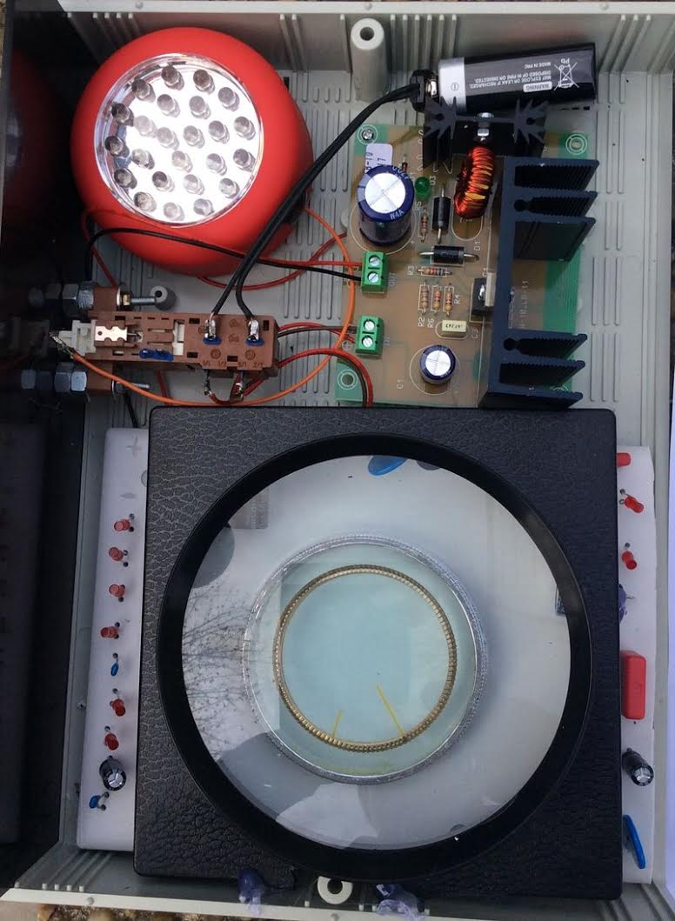
​
Realization of the method of normalization, during the concentration described in the patent “Method of prevention of catastrophes and device for its realization” is carried out through superposition of the bio-signal generated fields, electromagnetic fields. In addition to the factor of psychology according to the law of action of universal connections, a control of the goal of concentration is added.
The device universally works for the development of the following concentrations ensuring eternal life:
Control 1:
Development of eternal life concentrations for any event.
Control 2:
Development of eternal life concentrations for controlling clairvoyance
Control 3:
Development of eternal life concentrations for controlling forecasting.
Control 4:
Development of eternal life concentrations for rejuvenation.

The inventor of the device “PRK – 1U” is Grigori Petrovich Grabovoi

The producer of the device is Individual entrepreneur "GRIGORII GRABOVOI PR KONSALTING TECHNOLOGIES OF ETERNAL DEVELOPMENT" who operates on the basis of the certificate of state registration of individual Grigori Petrovich Grabovoi as an individual entrepreneur №63983276 issued on September 21. 2015 by the Agency for the registration of enterprises of the Republic of Serbia.
Time of the testing of the device:
Date:_________________________________
Time:_________________________________
The methods of use of the device:

Methods of use were the following: concentration on the goal of control 1, 2, 3, 4 is carried out within the time interval from 1 to 3 minutes and longer if necessary, with the device switched off and with the device switched on. The results are compared in terms of development effect of the concentrations ensuring eternal life. This effect is applied for the development of concentrations on specified controls through repeated use of the device.

The results of the use of the appliance:

Control 1:
Development of eternal life concentrations for any event.

Description of concentration before switching on the device:
_______________________________________________________________________________________________________________________________________________________________________________________________________________________________________________________________________________________________________________________________________________________________________________________
Description of concentrations after switching on the device:
_______________________________________________________________________________________________________________________________________________________________________________________________________________________________________________________________________________________________________________________________________________________________________________________
Conclusion:
_______________________________________________________________________________________________________________________________________________________________________________________________________________________________________________________________________________________________________________________________________________________________________________________
Control 2:
Development of eternal life concentrations for controlling clairvoyance
Description of concentration before switching on the device:
_______________________________________________________________________________________________________________________________________________________________________________________________________________________________________________________________________________________________________________________________________________________________________________________
Description of concentrations after switching on the device:
_______________________________________________________________________________________________________________________________________________________________________________________________________________________________________________________________________________________________________________________________________________________________________________________
Conclusion:
_______________________________________________________________________________________________________________________________________________________________________________________________________________________________________________________________________________________________________________________________________________________________________________________
Control 3:
Development of eternal life concentrations for controlling forecasting.
Description of concentration before switching on the device:
_______________________________________________________________________________________________________________________________________________________________________________________________________________________________________________________________________________________________________________________________________________________________________________________
Description of concentrations after switching on the device:

____________________________________________________________________________________________________________________________________________________________________________________________________________________________________________________________________________________________________________
Conclusion:
_______________________________________________________________________________________________________________________________________________________________________________________________________________________________________________________________________________________________________________________________________________________________________________________
Control 4:
Development of concentrations of eternal life for rejuvenation.
Description of concentration before switching on the device:
_______________________________________________________________________________________________________________________________________________________________________________________________________________________________________________________________________________________________________________________________________________________________________________________
Description of concentrations after switching on the device:

___________________________________________________________________________________________________________________________________________________________________________________________________________________________________________________________________________________________________________Conclusion:
_______________________________________________________________________________________________________________________________________________________________________________________________________________________________________________________________________________________________________________________________________________________________________________________
The general conclusion about the operability of the device on the development of the concentrations of eternal life: ____________________________________________________________________________________________________________________________________________________________________________________________________________________________________________________________________________________________________________________________________________________________________________
Date:_________________________________________
First name:________________________Second name______________________________

